Slovenská vodohospodárska spoločnosť, člen ZSVTS
Výskumný ústav vodného hospodárstva v Bratislave
Slovenská vodohospodárska spoločnosť pri VÚVH, člen ZSVTS
Zväz slovenských vedeckotechnických spoločností
Slovenské národné múzeum v Martine – Múzeum Andreja Kmeťa

invites you to

identification course for hydrobiologists

the Stoneflies (Plecoptera) of Slovakia - larvae

PART XI.

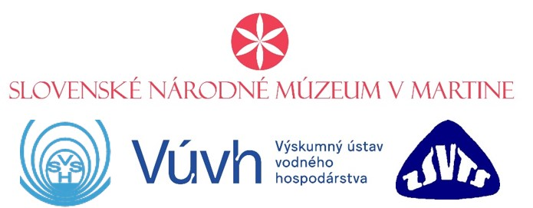

6. – 8. November 2024

Bratislava
Tentative course program:
Registration of participants: 6 November 2024 from 12:00 pm to 1:00 pm
Course start: 6. 11. 2024 at 1:00 pm
End of the course: 8. 11. 2024 at 12:00 pm

6. 11. 2024 1:00 pm – 5:00 pm
- Morphology, biology, ecology of stoneflies larvae and their distribution in Slovakia
7. 11. 2024 9:00 am – 12:00 pm
- Studying larvae morphological features with references to identification key (images presentation)
12:00 pm – 1:00 pm Lunch break
1:00 pm – 5:00 pm.
- Studying larvae morphological features with references to identification key (images presentation)
8. 12. 2023 9:00 am – 12:00 pm
- Discussion and identification of the biological material (possibility to identify your own material)

Instructors:
RNDr. Matej Žiak, PhD. (Andrej Kmeť Museum of the Slovak National Museum in Martin)

Course participants have the opportunity to consult their own material. The output of the course will be a text-book with a determination key.

General instructions:
Venue: VÚVH, Nábr. arm. gen. L. Svobodu 5, Bratislava (conference room on the 5th floor)
Participation fee: €240; students €100; (the fee includes costs associated with the organization of the course, refreshments, Identification key as part of the proceedings - in Slovak and English)
Please send the application form by 4th October 2024. The participation fee must be paid no later than 15th October 2024 to the WRI account:

IBAN: SK9209000000000011466172
BIC-SWIFT kód: GIBASKBX
Slovenská sporiteľňa, a. s., Tomášikova 48, 832 37 Bratislava
Variabilný symbol: 06112024
Konštantný symbol: 0308

Invoicing entity:

Slovenská vodohospodárska spoločnosť, Koceľova 15, 815 94 Bratislava

Buisness ID: 30807662, Tax ID: 2021457570
SVHS is not subject to VAT.
In the message to the recipient, enter the name, registered office of the organization and the names of the participants for whom the payment is made.
When paying from abroad, all bank fees are paid by the principal. Use the command "OUR" so that the amount comes to the organizer's account in full.
We will have to invoice any arrears.
In case of non-participation in the course, the deposit is not returned, it is possible to send a substitute.

Transportation:
- from the main railway station by bus no. 93 to the Zochova stop → change to bus no. 39, 31 to the Lanfranconi stop.
- from the bus station by bus no. 70 to the Nový most terminal → from there bus no. 37 or tram no. 4 to the Lanfranconi stop.

We do not provide accommodation, you can contact the nearest hotels:
hotel Družba, Botanická 25, 841 04 Bratislava, tel.: +421 2 654 200 65; +421 2 602 991 11 e-mail: recepcia@druzba.uniba.sk
hotel Sorea Regia, Kráľovské údolie 6, 811 02 Bratislava, tel.: +421 2 321 128 70, e-mail: regia@sorea.sk
botel Gracia, Rázusovo nábrežie, 811 02 Bratislava, tel.: +421 2 544 32 132, e-mail: hotel@botelgracia.sk
botel Pressburg, Dvořákovo nábrežie, 811 02 Bratislava, tel.: 0903 535 075 (please check availability)
Apartments Lanfranconi, Nábr. arm. gen. L. Svobodu 40, 811 02 Bratislava, tel.: +421 905 790 591; +421 905 790 589
Or try: http://www.travelguide.sk

Travel, meals and accommodation are not included in the participation fee.

Personal data protection
We will process common personal data, especially titles, first and last name, employer data, mailing address, e-mail address, telephone number and photographic material taken during the course.
The participants’ personal data will be processed and used in accordance with the applicable legislation of Slovakia and the EU.
The provision and processing of the above-mentioned data is necessary for participation in the event.
Do not hesitate to contact as should you have further questions about the details of personal data protection, at svhsvv@gmail.com.
Binding application form

Identification course for hydrobiologists
The stoneflies (Plecoptera) of Slovakia - larvae
6 – 8 November 2024

Name, surname, title: …………………………………………………………………………………….
Name of organization (as it should be at the invoice): ……………………………..…………………....
……………………………………………………………………………………………………………
Address of organization: ………………………………………………………………………………… ………………………………………………………………………………………………………........
Bank details: ……………………………………………………………………………………………..
IBAN: …………………………………………………………………………………………………….
Buisness ID: …………………… Tax ID: …………………….. VAT reg. Num.: ………………….…
Tel./fax.: ………………………………………………………………………………………………….
e-mail: ……………………………………………………………………………………………………

Stamp and signature of the employer

The filled application form should be sent by no later than 15th October 2023 to the address:

Mgr. Margita Lešťáková, PhD., Water Research Institute, Bratislava

Nabr. arm. gen. L. Svobodu 5, 812 49 Bratislava

tel.: +421-02-59343 415 or by e-mail to the address: margita.lestakova@vuvh.sk

Invoicing entity:

Slovenská vodohospodárska spoločnosť, Koceľova 15, 815 94 Bratislava

Buisness ID: 30807662, Tax ID: 2021457570

